Using IBM Analytics Demo Cloud
- Go to Google site and search for IBM Analytics Demo Cloud.

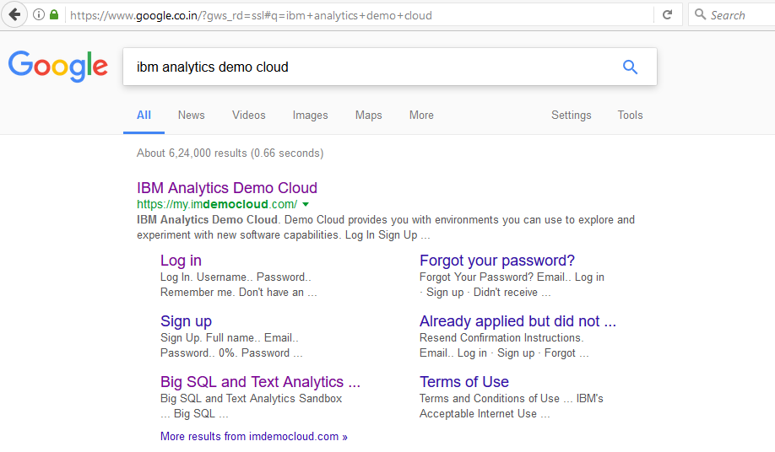

- Go to the https://my.imdemocloud.com website.

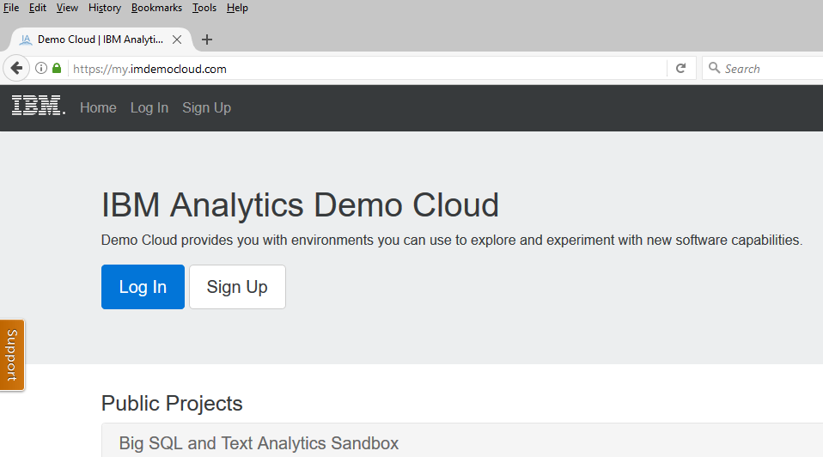

Click on Sign Up button to register for the service. This step is for the first time only. Once you register and your account is created you get access to the cloud services.

** Currently the cloud service is free but IBM may change policy

When you click on the Sign Up button following Window opens.

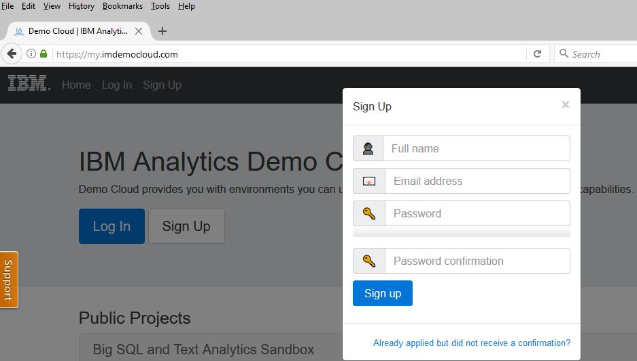

Provide Full Name and Email address. Provide password. Click Sign Up.

You will receive a confirmation email. It will provide you all the access details.

- You need to install Putty software which allows you to remotely access a computer.

Double click on the above installer file.

The following screen will open.
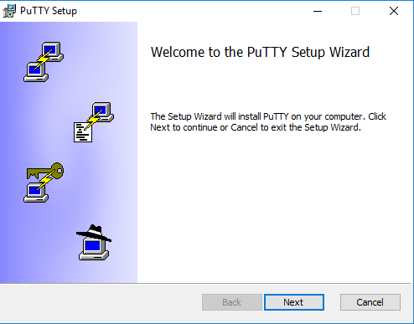

Click Next. The following screen opens. It allows you to select directory where the Putty software will be installed. Click Next.

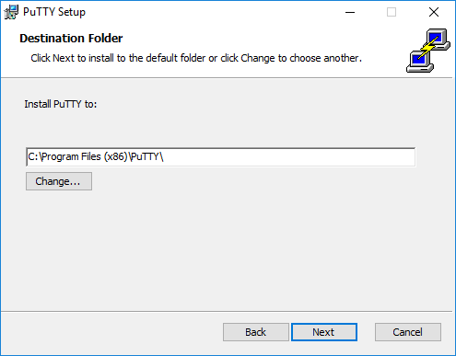

The following screen opens.
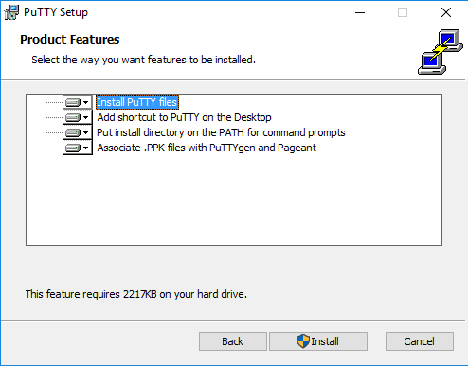

Click Install to start Installation. If you have not logged in as Administrator, it may prompt you for a password.

The installation will proceed. The following screen is displayed when it finishes.

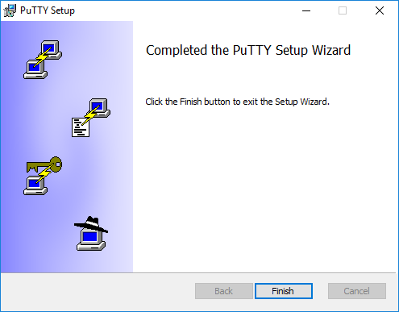

Click Finish to complete the installation.

Now log in to the https://my.imdemocloud.com site with your username and password.
Once you login click on the following tab on the site.

Big SQL and Text Analytics Sandbox
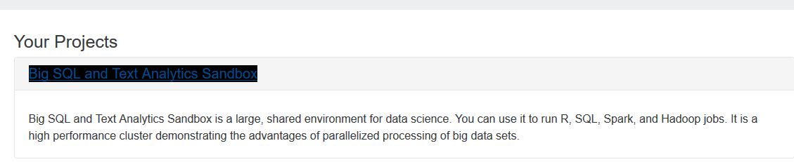

On the page that opens, click the systems tab as shown below.

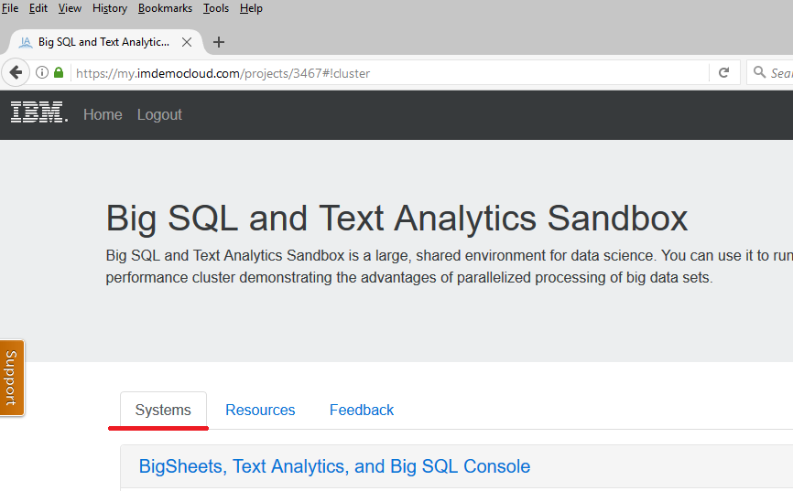

On that page scroll down and go to the connection details section. In that section the ssh connection information is given. Copy the full name after ssh . This is shown below marked with a red line.

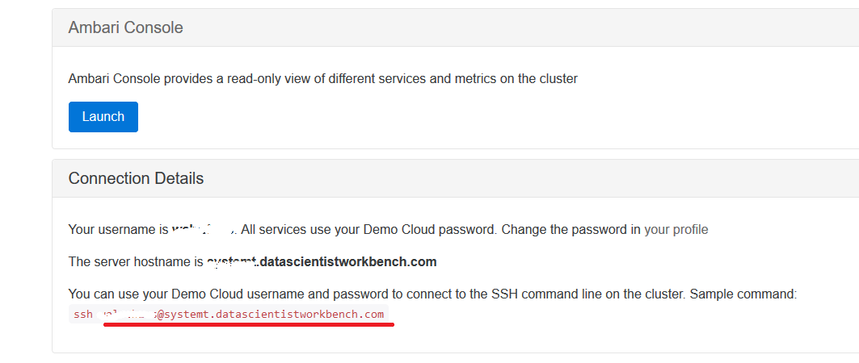

After that double click the following icon on the desktop.

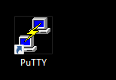

This will start the putty program. The following screen opens.

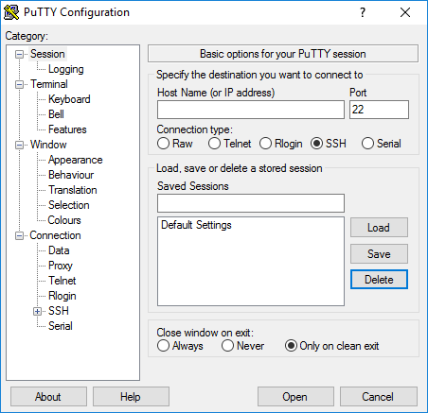

Now paste the username@systemname that was copied in the above step in the Host Name field. This is as shown below.

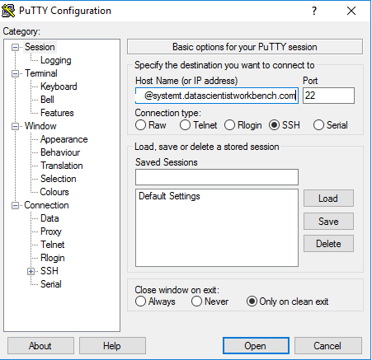

Then click Open button a command window will open as shown below. It will prompt for the password. Specify the same password that you used to login to IBM cloud site.

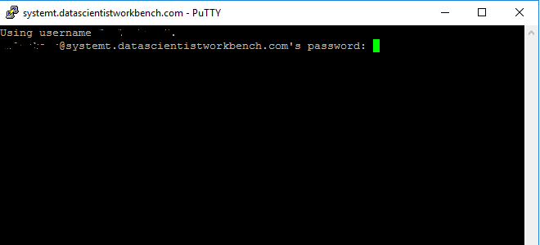

Once you type the correct password the system will provide a command prompt. This is as shown below.

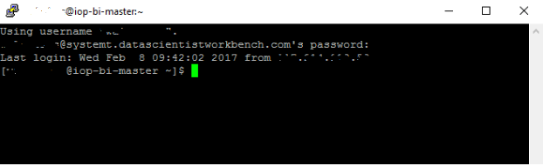

This a Linux system with Hadoop pre-installed. Just run some Hadoop commands as show below.

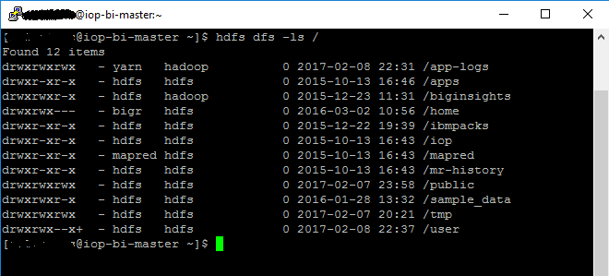

Thus now you can execute your Hadoop applications on this cloud computer.

To copy data from your local machine to this cloud system a utility called WinSCP is used. The following steps guide you through installation of WinSCP and its use.

Double click the following installer.



It will start installation process. The following screen will be displayed. It may prompt for the administrator password if you have not logged in as administrator.

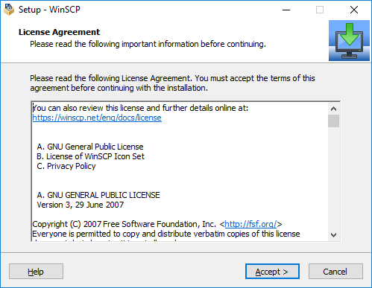

Click Accept.

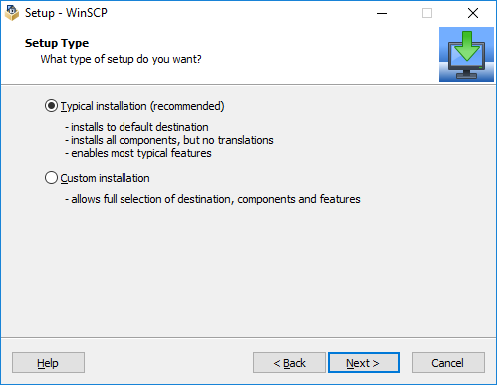

Click Next on the above screen.

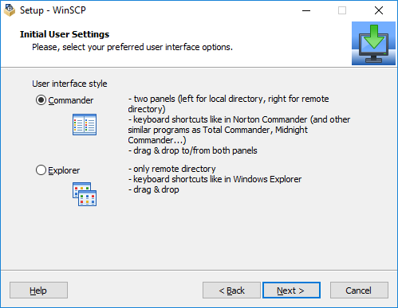

Click Next on the above screen.

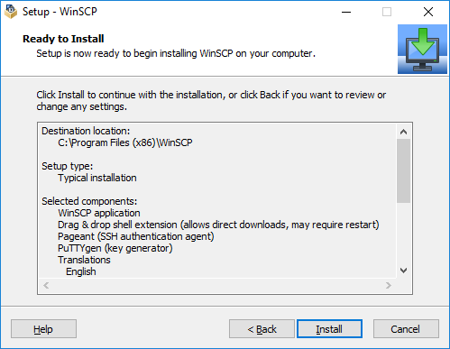

Click Install.
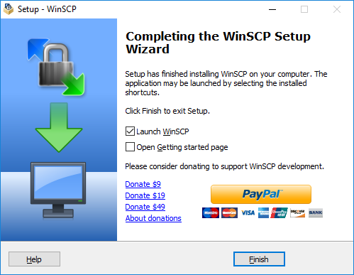
Uncheck the required boxes. Click Finish.
This installs WinSCP on your computer.

Now using WinSCP trasfer required files to the IBM cloud computer.

Open WinSCP. The following window opens.

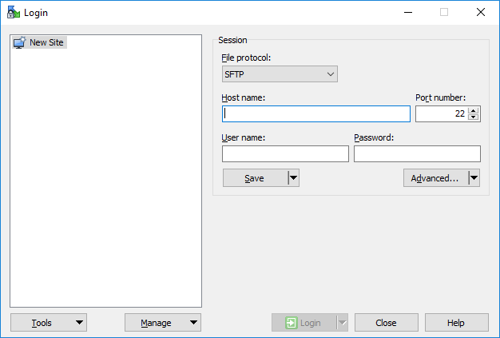

In the host name field paste the username@systemname information copied from the connection details page of IBM cloud site. Also provide your username and password. This as shown below.

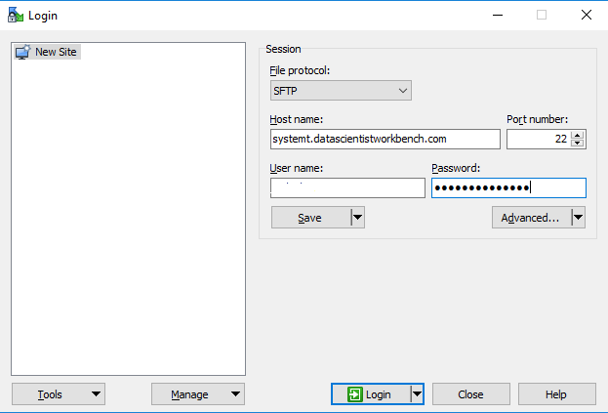

Click Login. Once you login successfully the following screen opens.

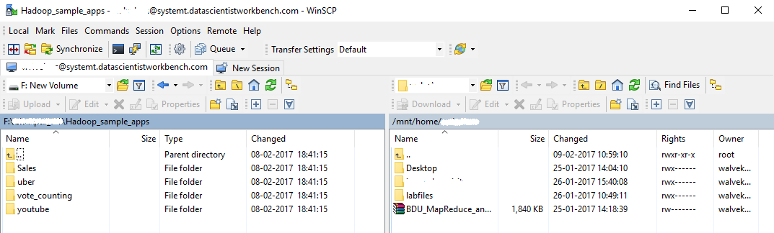

In the above window the left pane displays the files on your computer. The right side pane displays the files on the cloud computer. Now copy the required files to the cloud computer.

To copy the files just select the folder or file that you want to copy, drag and put it on other side.
Now just type ls in the putty session window and you will be able to see the new data.

You can copy this data to hadoop and run your applications on the IBM cloud computer.

